Date & Time: January 27, 2020; 4.00 pm -6.30pm
Rotary Club of Sangli, 5th Ln, Ganesh Nagar, Sangli, Maharashtra 416416

In the coming years, India's economic growth will be significantly driven by commodity production, processing, consumption and trade. By their very nature, commodity markets are volatile. Therefore it is necessary for producers, FPO’s, processors, industrial consumers, exporters and importers of commodities to manage their price risks through hedging which is an insurance against adverse price movement. To advance this idea IMC Chamber of Commerce and Industry is organizing a Seminar on "Commodities as India’s Building Blocks’.
This event is supported by MCX-IPF and ITnium, Sangli.
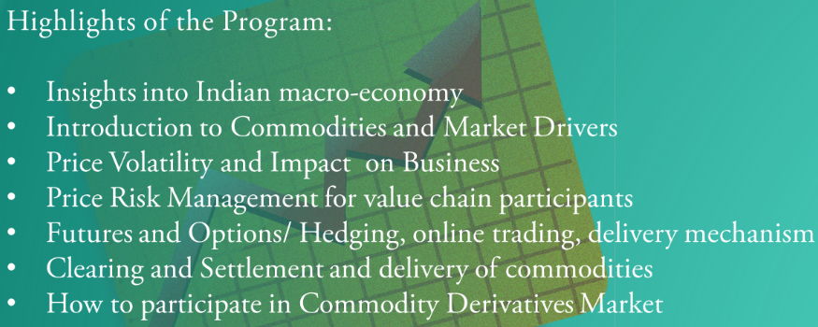
REGISTRATION
ITnium 2nd Floor, Creative Plaza,
Ram Mandir- Civil Hospital road, Sangli
Email: anita.naik@imcnet.org
itnium@rediffmail.com
Contact No- 9423868881

We cordially invite you to attend this seminar. Kindly note it’s a FREE event, but registration is MANDATORY. We look forward to your participation. We will appreciate a line in confirmation of your participation with your name/company/contact details.
We look forward to welcoming you.

Ajit Mangrulkar
Director General,
IMC Chamber of Commerce and Industry

